

WEB Database Programming Project Report

Department: Computer Science and Engineering

Semester: Spring-2017

Course Code: CSE-480

Course Title: WEB Database Programming

Project Title: BD Professionals

**Submitted By :**

S. M. Ruhul Kabir Howlader

ID: 2014-2-60-089

Section No: 01

**Submitted To:**

Bijan Paul

Senior Lecturer

Department of Computer Science & Engineering

**Date of Submission**: *23rd April 2017*

**Abstract**

In Bangladesh so many students, professional worker and repairmans are searching works and also want to give workers. There is so many websites is serving for that type of works. But all of those companies are operated froom outside of this country. These organizations may not understand the human psychology of Bangladesh. BD Professionals is the website that make for the people of our country. It can be helpful on many different perspective.

**Table of contents**

|  |  |
| --- | --- |
| **Number** | **Title** |
| 1 | Introduction |
| 2 | Objectives |
| 3 | Scope of the software |
| 4 | Requirement Analysis |
| 5 | Database Design and System Layout Diagram |
| 6 | System Requirement |
| 7 | Packages, APIs and libraries used |
| 8 | Screen shots of Project |
| 9 | Future plan |
| 10 | Conclusion |
| 11 | References |

**Introduction**

I develop this website for the freelancers, finding repairmans for daily life. This software name is **BD Professionals** where a user can give any kind of work in online, freelanching and also find any kind of repairmans for his/her daily problems.

**Objectives**

* Main objectives of this project is to finding the professional workers and mechanic. Our everyday life we faced so many problems like problems in electronic switches and searching for electricians or so many other problems. For the solutions we take help from other and went to different stores. This project main objective is to find those repairmans contact informatin sorted by their location.
* Not only the repairmans this project will be helpful for the freelancers. Finding the online workers this website will be helpful for us. Suppose someone want to build a project on C#. He can hire a switable worker for his project.

**Scope of the software**

We know that in our country many freelancers are working for many different type of freelanching websites like Odesk. Odesk and most of the other companies are opreated from outside of Bangladesh. Most of the time the did not understand the psychology of our people. Not only this we face many problems in daily life where we need elictricians, plumbers and other repairmans.   
So, this website will be more easier for those who need these type of work.

**Requirement Analysis**

* Finding any kind of repairman for daily errors.
* Finding and hire the professional project makers and others.

Requirements are given below

1. Sign up
2. Login
3. View Repairman
4. Update/delete Account
5. Give offers
6. View/Apply for offers
7. Search/View Freelancers
8. Make Approvals of own offers
9. Logout

**Database Design**

Database of this project is design to user can hire the professional user and view the repairmans. To understand the whole database class diagram, E-R diagram, use case diagram is draw the later part of this proposal. MySQL will be used for this project.

***Use Case Diagram***

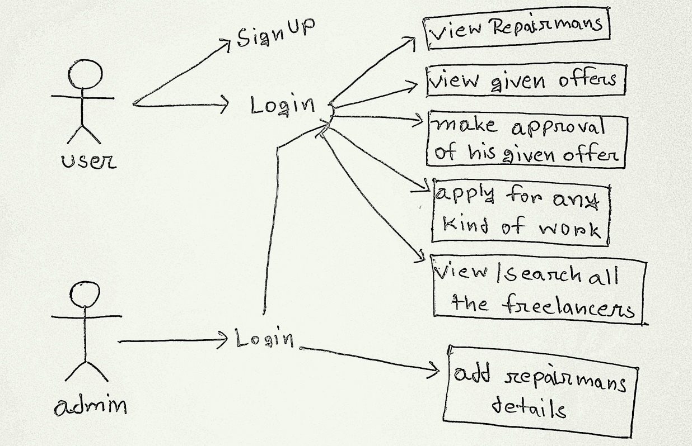

***E-R Diagram***

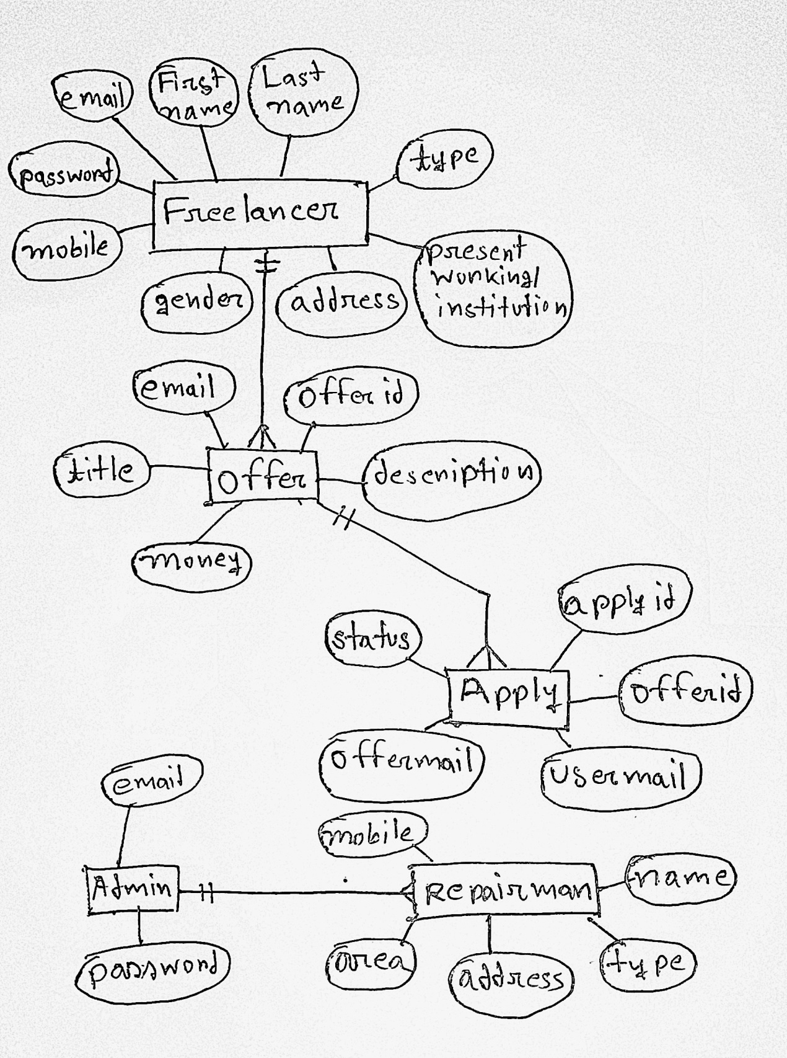

**System Requirement**

* **Browser:** Chrome, Firefox, Safari, Microsoft Edge.
* **RAM:** 512mb or higher
* **OS:** Microsoft windows XP, Vista, 8, 8.1, 10, Linux, Mac-OS
* MySQL server, Xampp, Apache server

**Packages, APIs and libraries used:**

Here used only bootstrap-3.2.0-dist.

**Screen shots of Project**

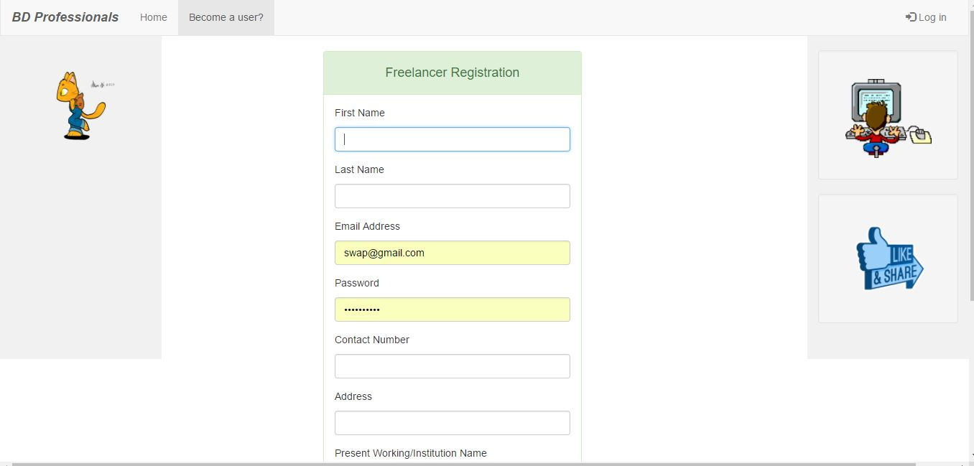

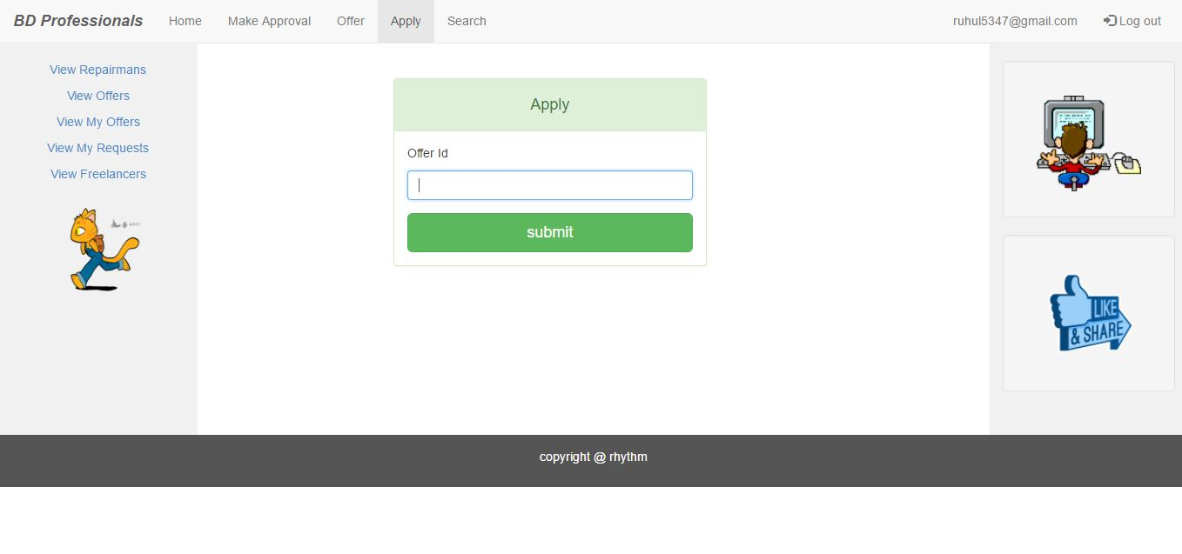  
  
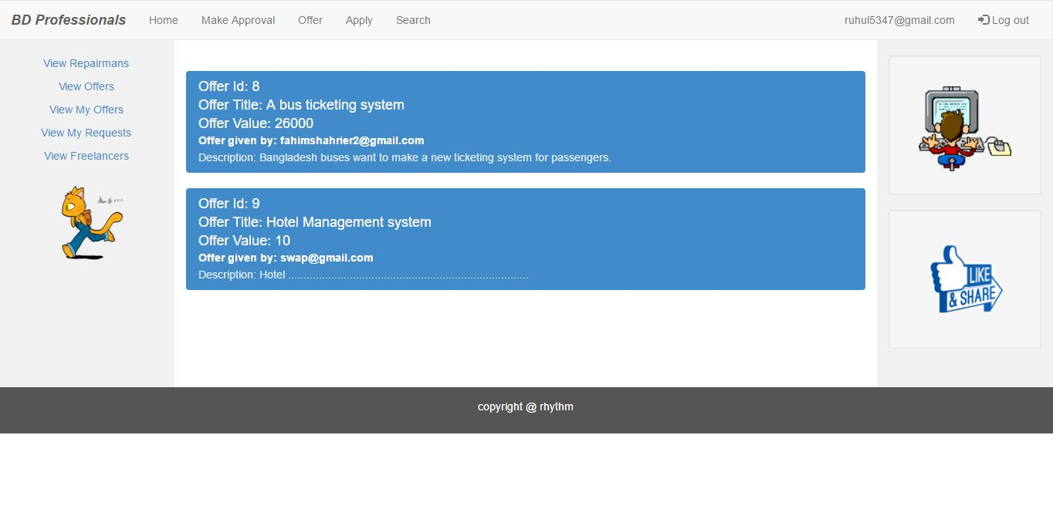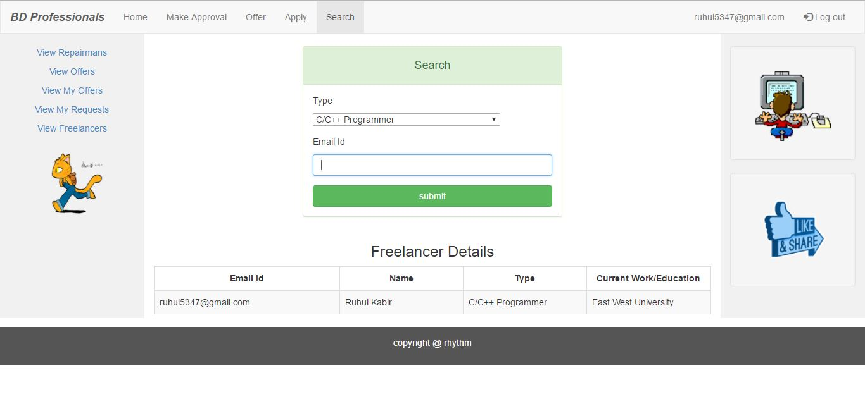  
  
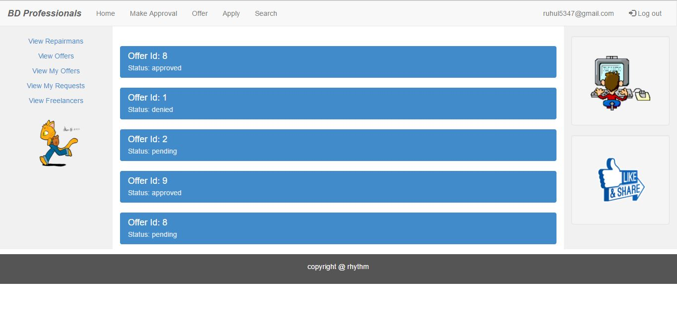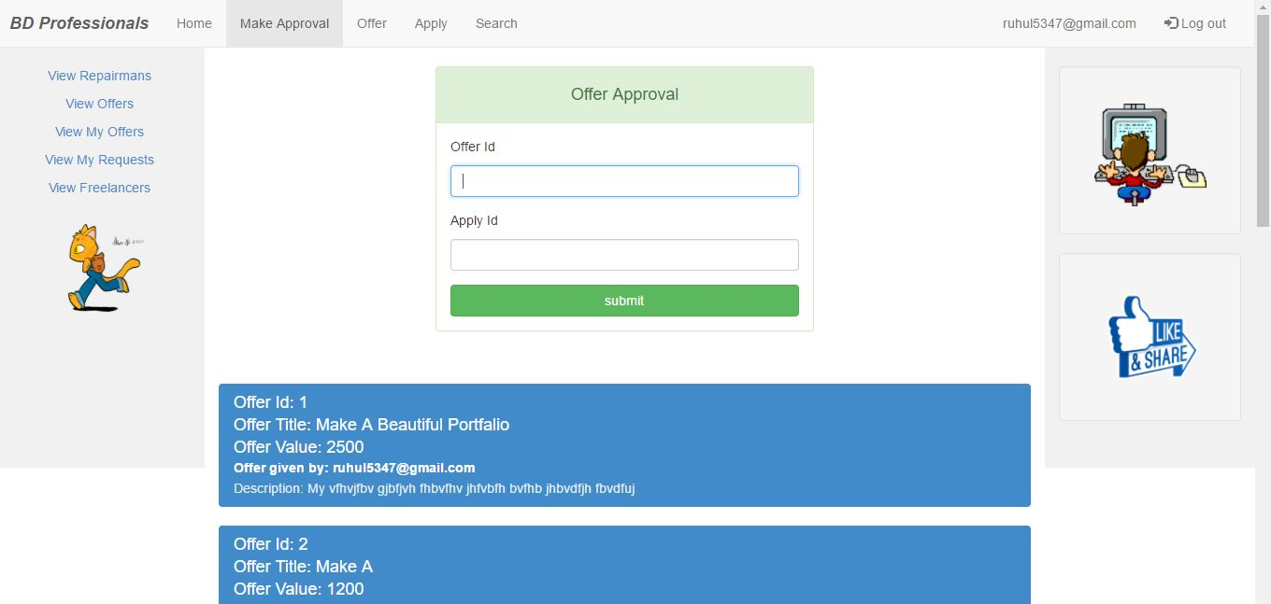  
  
  
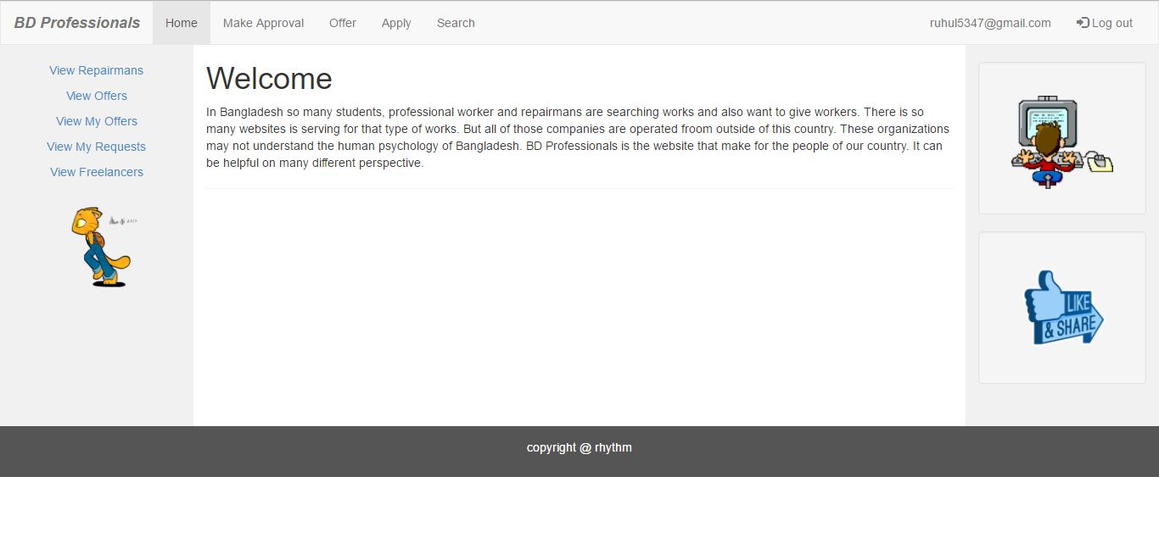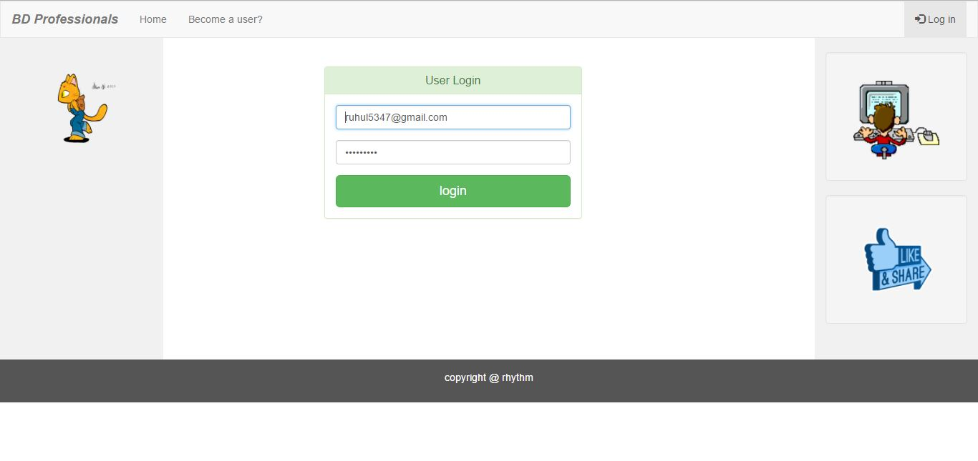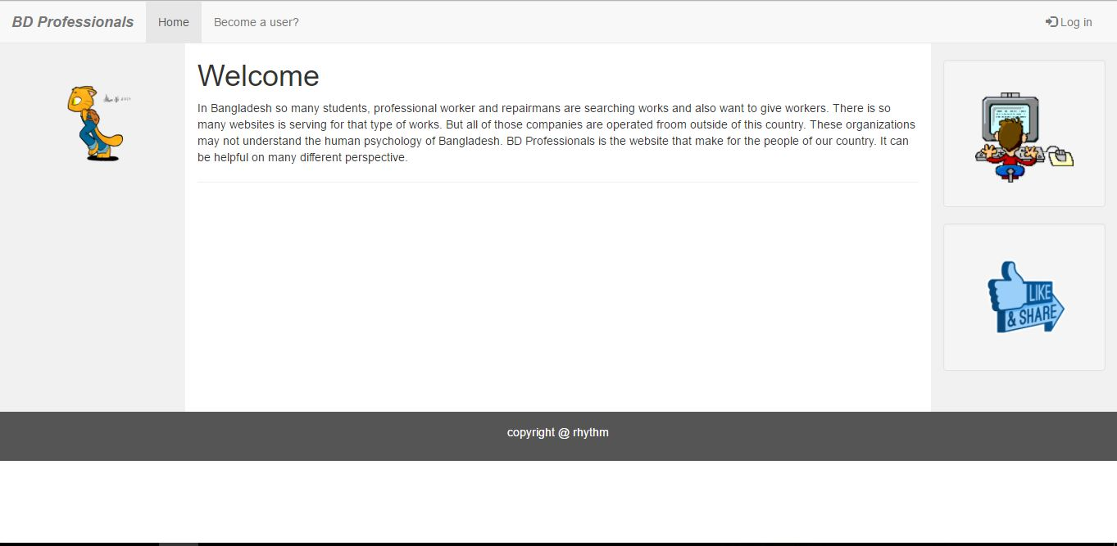

**Future plan:**

Future plan of this project is to make more user friendly environment for the freelancers, users. When I working with this project I feel that the Graphical User Interface was not so well designed. User also may find so many bugs. There is only I give a platform for work give and received, no money debit or credit is happening. It will be helpful when user can find this type of environments. For finding repairmans I will be visited all the area for collecting proper information about the repairmans.

**Conclusion:**

I tried to make this project as good as possible. But there maybe some or many bugs when a user can run this program. In spite of there are many problems with this website user can also make use of this website as he/she needed.

**References:**

* <https://www.w3schools.com/bootstrap/>
* <https://www.w3schools.com/bootstrap/tryit.asp?filename=trybs_temp_webpage&stacked=h>